March 11, 2022

Matthew Holden, Chairperson
Advisory Neighborhood Commission 2B
#9 Dupont Circle, NW
Washington, DC 20036
Via Email: 2B08@anc.dc.gov; 1B09@anc.dc.gov

NOI# 22-93-TOA

Re: Removal of two parking spaces and replace with ADA at 1500 block of Caroline Street NW

Dear Chairperson Holden:

Pursuant to the “Administrative Procedure Amendment Act of 2000” D.C. LAW 13-249 (48 DCR 3491 April 20, 2001), the District Department of Transportation (DDOT) is required to give a written notice of our intent to modify traffic and/or parking requirements. This letter is being forwarded to you for the purpose of notification and solicitation of comments on our intent to implement the following in your jurisdiction.

DDOT will be removing two on-street parking spaces (Resident Permit Parking for Zones 1 & 2) nearest the alley on the south side of 1500 block of Caroline Street NW. In this location, DDOT will install two ADA parking spaces to accommodate persons with disabilities that have RPP Zone 1 or 2 permits. This is part of a pilot program to expand the District’s ADA parking program for residents that are not eligible for the Reserved Disability Parking Program. Please see diagram below.

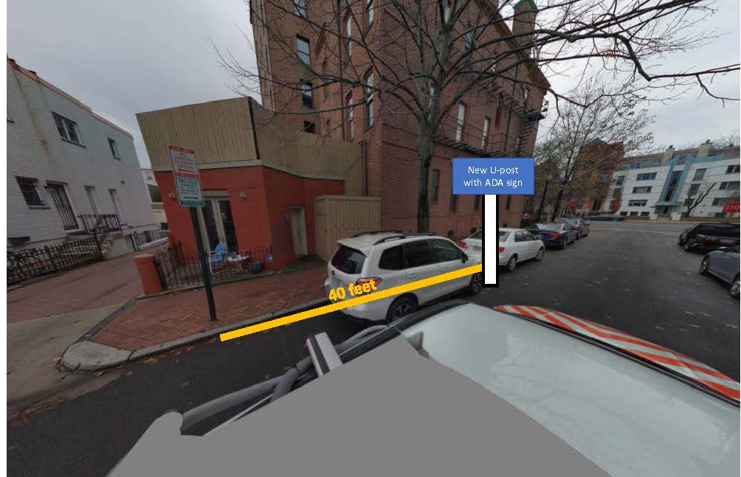

Details of drawing subject to change, but the parking removal locations will not change.

All comments on this subject matter must be filed in writing by April 25th (thirty business days after the date of this notice), with the District Department of Transportation, Transportation Operations Administration, 250 M Street, S.E. Washington, D.C. 20003. If you would like to check the status of this Notice of Intent (NOI), please visit DDOT’s website at https://ddot.dc.gov/service/ddot-notice-intent. If you are having any trouble accessing the NOI site or unable to do so, please contact the DDOT Customer Clearinghouse at 202-671-2800.

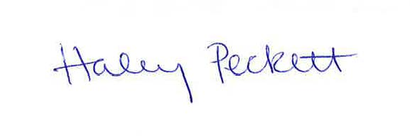
Sincerely,

Haley Peckett, AICP
Associate Director
Parking and Ground Transportation Division
District Department of Transportation

CC: Kyle Mulhall, SMD 2B09
James Turner, ANC 1B Chair
Nyasha Smith, Secretary to the Council of the District of Columbia
Donovan Boyd, Community Engagement Specialist, DDOT

Language Access Statement
The District Department of Transportation (DDOT) is committed to ensuring that no person is excluded from participation in, or denied the benefits of, its projects, programs, activities, and services on the basis of race, color, national origin, gender, age, or disability as provided by Title VI of the Civil Rights Act of 1964, the Americans with Disabilities Act and other related statutes. In accordance with the D.C. Human Rights Act of 1977, as amended, D.C. Official Code sec. 2-1401.01 et seq. (Act), the District of Columbia does not discriminate on the basis of actual or perceived: race, color, religion, national origin, sex, age, marital status, personal appearance, sexual orientation, gender identity or expression, familial status, family responsibilities, matriculation, political affiliation, genetic information, disability, source of income, status as a victim of an intrafamily offense, or place of residence or business. Sexual harassment is a form of sex discrimination which is prohibited by the Act. In addition, harassment based on any of the above protected categories is prohibited by the Act. Discrimination in a violation of the Act will not be tolerated. Violators will be subject to disciplinary action.

If you need special accommodations or language assistance services (translation or interpretation) please contact Cesar Barreto at 202-671-2829 or Cesar.Barreto@dc.gov.

If you need language assistance services (translation or interpretation), please contact Karen Randolph at 202-671-2620 or Karen.Randolph@dc.gov.

AYUDA EN SU IDIOMA

Si necesita ayuda en Español, por favor llame al 202-671-2700 para proporcionarle un intérprete de manera gratuita.

AVISO IMPORTANTE

Este documento contiene información importante. Si necesita ayuda en Español o si tiene alguna pregunta sobre este aviso, por favor llame al 202-671-2620. Infórmele al representante de atención al cliente el idioma que habla para que le proporcione un intérprete sin costo para usted. Gracias.

AIDE LINGUISTIQUE

Si vous avez besoin d’aide en Français appelez-le 202-671-2700 et l’assistance d’un interprète vous sera fournie gratuitement.

AVIS IMPORTANT

Ce document contient des informations importantes. Si vous avez besoin d’aide en Français ou si vous avez des questions au sujet du présent avis, veuillez appeler le 202-671-2700. Dites au représentant de service quelle langue vous parlez et l’assistance d’un interprète vous sera fournie gratuitement. Merci.

GIÚP ĐỠ VỀ NGÔN NGỮ

Nếu qu‎ý vị cần giúp đỡ về tiếng Việt, xin gọi 202-671-2700 để chúng tôi thu xếp có thông dịch viên đến giúp qu‎ý vị miễn phí.

THÔNG BÁO QUAN TRỌNG

Tài liệu này có nhiều thông tin quan trọng. Nếu qu‎ý vị cần giúp đỡ về tiếng Việt, hoặc có thắc mắc bề thông báo này, xin gọi 202-671-2700. Nói với người trả lời điện thoại là qu‎ý vị muốn nói chuyện bằng tiếng Việt để chúng tôi thu xếp có thông dịch viên đến giúp qu‎ý vị mà không tốn đồng nào. Xin cảm ơn.

የቋንቋ እርዳታ

በአማርኛ እርዳታ ከፈለጉ በ 202-671-2700 ይደውሉ። የነፃ አስተርጓሚ ይመደብልዎታል።

ጠቃሚ ማስታወቂያ

ይህ ሰነድ ጠቃሚ መረጃ ይዟል። በአማርኛ እርዳታ ከፈለጉ ወይም ስለዚህ ማስታወቂያ ጥያቄ ካለዎት በ 202-671-2700 ይደውሉ። የትኛውን ቋንቋ እንደሚናገሩ ለደንበኞች አገልግሎት ተወካይ ይንገሩ። ያለምንም ክፍያ አስተርጓሚይመደብልዎታል። እናመሰግናለን።

언어 지원

한국어로 언어 지원이 필요하신 경우 202-671-2700로 연락을 주시면 무료로 통역이 제공됩니다.

안내

이 안내문은 중요한 내용을 담고 있습니다. 한국어로 언어 지원이 필요하시거나 질문이있으실 경우202-671-2700 로 연락을 주십시오. 필요하신 경우, 고객 서비스 담당원에게 지원 받고자 하는 언어를 알려주시면, 무료로 통역 서비스가 제공됩니다. 감사합니다.

語言協助

如果您需要用（中文)接受幫助，請電洽202-671-2700, 將免費向您提供口譯員服務

重要通知

本文件包含重要資訊。如果您需要用（中文）接受幫助或者對本通知有疑問，請電洽202-671-2700。請告訴客戶服務部代表您所說的語言，會免費向您提供口譯員服務。謝謝！

