DDOT Library Policies and Procedures Manual
Table of Contents
1.) Collection Description 2
2.) Collection Development/Management Policy 2
3.) Circulation Policies 11
4.) Cataloging Rules 12
5.) EOS How-Tos 12
6.) Reference Services 13
7.) Literature Searches and Market Scans 13
8.) Emergency Procedures 15
9.) Volunteer and Intern Policies 31
10.) Archives and Photographic Archives Policies 31
11.) Historical Section Policies 32
12.) CD and DVD Policies 32
13.) Outreach 32
14.) Web Page 32

1.) Collection Description
The DDOT library contains various types of materials, including physical copies of books, reports, studies, serials, periodicals, maps, and CDs, as well as a smaller selection of electronic documents. Our wide-ranging general collection includes publications from DDOT, USDOT, FHWA, AASHTO, TRB, ITE, as well as a number of reports and studies from both DDOT and outside consulting firms that are available for checkout. The reference collection contains extra copies of the majority of the most highly used titles as well as the DCMR, DC Code, and a selection of federal regulations. We also hold several Baist books that are available for patrons to use and make copies of, but they cannot be taken out of the library aside from special circumstances. The historical section is comprised of materials from the late 1890s through the early 1990s. We also house a growing collection of TRB serials that come to us a few times a month, as well as a small collection of training documents and DVDs. The library holds a small archival collection, which includes historical documents and correspondence from the late 1800s and early 1900s, as well as newspaper clippings and public meeting notes. Lastly, the library contains an expansive collection of photographs, both historical and modern. Eventually all the general, historical, serial, and multimedia collections will be cataloged into EOS, and all the archival documents and photo digitized and collected into Omeka.

2.) Collection Development/Management Policy
I. Selector/Librarian Contact Information
Librarian: Kathleen Crabb (M.S.L.I.S, Catholic University of America)
Email: Kathleen.Crabb@dc.gov
Phone: 202-478-9122
Website: https://sites.google.com/a/dc.gov/ddot-research-program/ddot-library
General DDOT Mission Statement:
To develop and maintain a cohesive, sustainable transportation system that delivers safe, affordable, and convenient ways to move people and goods while protecting and enhancing the natural environment and cultural resources of the District.
DDOT Library Mission Statement:
The purposes of the DDOT library are to preserve and create access to District of Columbia transportation history as well as providing a central source of current information, statistics, decisions, texts and other literature serving the needs, first and foremost, of the DDOT employees along with outside researchers, consultants, other District government or federal employees, and the public.
II. Overview of the Collection
Collection History:
The District Department of Transportation Library started in March of two-thousand-eleven, with the agency’s move to new offices in downtown DC from U street. The goal was to organize, catalog and preserve the current collection, as well as taking in new publications. There had previously been a small collection that was managed by a part-time librarian who left in the early 1990s. The collection was then abandoned until a historian was hired in two-thousand-five to manage the fairly small collection; after the move to 55 M Street and the announced start-up of the official library, over three-hundred boxes of donations were made, largely consisting of materials that had previously been kept at the employees’ desks. Starting the library allowed all employees to have a central location in which to look for needed materials and conduct research for studies, current and future DC transportation projects and scholarly studies.
Major Units/Programs Served:
- The Office of the Director (OD)
- Infrastructure Project Management Administration (IPMA)
- Policy, Planning and Sustainability Administration (PPSA)
- Progressive Transportation Services Administration (PTSA)
- Transportation Operations Administration (TOA)
- Urban Forestry Administration (UFA)
- Consultants from outside Engineering Firms
- District of Columbia Government
III. Description of Materials Collected
Circulating Collection:
- Engineering Manuals
- Environmental Studies and Manuals
- Transportation Research Board Serials
- American Association of State Highway Officials Serials and other publications
- Assorted Periodicals
- Federal Highway Administration and United States Department of Transportation Reports
- Specific District of Columbia Location Studies (i.e.: K street, Capitol Hill, Anacostia, etc)- Traffic, Transportation, Environmental
- Bike and Road maps
- Public Transit Materials- Washington Metropolitan Transit Authority, Railroads, Circulator Buses
- Highway Safety
- Bicycles and Pedestrians
- Pavements, soils, road-making materials
- Urban Forestry/Parks
- Parking
- Bridges
- Traffic Calming/Traffic Signals
- Design Manuals (Roads, Bridges, Bike Paths)
- General DC Government Materials
- Federal Government Materials
- Zoning/Land Use Materials
- Photographs of Construction Projects (Historical and Current)
- Motor Vehicles and Speed
- Historical Materials starting from 1898
- CDs
- DVDs
Reference Collection:
The collection contains a small non-circulating reference section, which holds Federal and DC Government law manuals, general dictionaries and encyclopedias, as well as one copy each of the most highly-used materials (when copies are available) in order that one copy will always be available if all the others have been checked out. All of these materials will remain in the library at all times, barring any sort of special circumstances.

Electronic Sources:
The DDOT library has access to the online publications of the Transportation Research Board, American Association of State Highway Officials, and The Federal Highway Association. We also keep a record of free internet websites that may be helpful to patrons, as well as PDF copies of studies that have been saved from the general DDOT P Drive.

Chronological Scope: 1898-Present
Geographical Scope:
The collection largely encompasses the District, but also includes materials from the DC metropolitan area as a whole, as well as materials from other state DOT’s and foreign countries.
Physical Materials:
Photos, CDs, DVDs, monographs, reports, maps, Baist books, artifacts, historical street signs, historical documents/correspondence
Future Emphasis:
The library mainly contains materials from PPSA, IPMA, and TOA, and the library would like to have additional materials from the other administrations such as Urban Forestry, the new streetcar project, and the very popular Capital Bike-share initiative. The DDOT library would also like to start an official electronic collection, aside from the already existing access to the online publications of TRB, AASHTO, and FHWA.

Special Collections:
The Historical section of the library contains materials which are over a century old, including the full set of original “Acts Affecting the District of Columbia” the first of which dates back to 1898, transportation studies from World War II, and research on the original District of Columbia Streetcars. The collection also contains a significant amount of archival materials, including correspondence from early transportation leaders and District Employees dating back as far as 1902, as well as some of the original schematics for the construction of Union Station.
Acquisitions Policy:
The library receives new TRB, AASHTO, Federal Highway Association, and USDOT publications, as well as various periodical titles as they are released, usually every few weeks, and a list of newly received publications is updated on the library webpage. Patrons may request the librarian purchase new materials, which are purchased and acquired at the discretion of the librarian (funding permitting). Items are chosen based on need, popularity, and diversity of use and all requested items are kept on a master list in order of priority. The library often purchases books for things like the PE, FE, PMP, and AICP exams through Training, and employees may come to the Library for requests. The Librarian keeps a list of requested acquisitions, along with the patrons who requested them so that when funding is available some of the requested books might be purchased.

Acquisitions Agreements:
The DDOT library has agreements that are renewed yearly with both the Transportation Research Board and The American Association of State Highway and Transportation Officials. For a yearly fee, each time a new publication is published by either of these associations they are sent directly to DDOT.
IV. Funding and Collection Value
Budgeting and Funding:
The librarian position was formerly funded through a contract with Howard University but was transitioned to a DDOT employee position in 2015. Our interns are funded through the DDOT university contract with Howard. The materials for the collection as well as general library supplies are usually purchased through general DDOT PPSA funds, or through funds from other administrations as needed.

Collection Value:
By maintaining these records, the library assists DDOT engineers, planners, consultants, and administrators to fulfill DDOT’s mission and maintain a safe, reliable, and aesthetically pleasing transportation infrastructure. The digitization of our archival and photo collections will also help create access to our unique collections both within and outside the agency to the larger community.
V. Withdrawal, Retention, and Circulation
As part of the regular DDOT Library collection development and maintenance procedures, library staff members regularly weed materials from the collection if they are irrelevant, superfluous or out of date and not of historical value. The library receives older donations from employees if the item is pertinent to the mission, as well as copies of all new studies and reports written by DDOT or its consultants.
The retention policy is to keep two-three copies of all relevant materials where possible, unless instructed by a member of a particular administration to keep more of any given item. Also, if an item is particularly high use, three or more copies will be kept on a case by case basis in the circulating collection, and another copy will be kept in the reference section so there will always be a copy available in the library. If a major new publication is released, three copies will be kept until the need for said publication decreases.
The following should be considered when weeding the collection:

- The current and ongoing needs of patrons
- Whether the resource is relevant to current or historical DC transportation
- Available space for shelving and storing the physical collection
- Condition of the material
- Rareness and value of the material
- Number of copies of the material. Is it a duplicate?
Retention Schedule:
Additionally, the following retention schedule will be consulted:

Publication Type | Number of Copies | Retention
DDOT Official publication | 2 or 3 copies | Permanent retention
DDOT (& sponsored) technical reports | 2 copies | Permanent retention
Statistical and other serial publications | 1 copy  (Due to space) | According to the Weeding Guidelines
Monographs | 2 copies | According to the Weeding Guidelines
Periodicals | 1 copies  (Due to space) | As long as space lasts, the library will keep all publications and revisit when space grows slim (older magazines are kept in a box rather than cataloged)
Congressional/Government Directories | 2 copies | Discard after a change in administration or when new directory comes (Can be placed in the historical section at the librarian’s discretion.)

Upon removal, materials should be discarded by the following methods in sequential order:
- Donation to other transportation libraries and organizations or DCPL Washintoniana
- Transfer to the DDOT or City Archive
- Discarding of material (if item is completely irrelevant, this will come first)

The rationales responsible for establishing this order of preference are as follows. If an item is available through another library and weeded locally, access can still be provided. If material is available through the State or DDOT Archives the same holds true. The option to discard material should be exercised as a last resort, and usually only occurs if the item is irrelevant or if there are multiple duplicates. Other than cost of shipment, materials will be offered without charge. Because these materials are government property, requests from individuals, collectors, or profit-making organizations cannot be honored. However, if a DDOT employee would like to keep a publication which already has multiple duplicates, their request will be considered, especially if the item might otherwise be discarded.
Libraries are given fourteen (14) days to respond to the notice of interest. If more than one library indicates interest in the same item, the library making the earliest request will be given the item.
VII. Gift & Donation Policy
The library accepts gifts and donations if they fall within the scope of the collection. Donations of material substantially contribute to the Library’s resources as the library is rebuilt. They supplement and enhance existing collections that support the research needs of staff and patrons. Materials that fall outside the collection scope or duplicate holdings may be discarded. The library receives many donations from DDOT employees who donate the books they kept at their desks in order that other employees might have access to the materials.

2016 addition: due to many donations of multiple copies of the same item and not wanting to run into space constraints, employees donating items will need to fill out a donation rubric. In order to keep track there is also a list kept by month/year of what has been donated.

VIII. Electronic Materials/Databases
Factors that should be considered in the selection of electronic resources:
- Content (Accuracy, Completeness, Updated at timely intervals, Audience defined)
- Cost
- User-Friendly interface
- Licensing which covers access, archiving of the electronic files over time, copyright and Inter-Library loan provisions
- Hardware and software requirements
- Availability of use statistics and reports
- Phasing out of the print and/or CD-ROM edition of a title
- Training to fully utilize the database
- Resources unavailable in other databases.
IV. Consortium/Cooperative Agreements
The DDOT Library would like to provide interlibrary loan services in the future in order to expand the range and number of resources available to DDOT employees and to share the library’s collections as widely as possible in compliance with the ALA Interlibrary Loan Code and applicable copyright laws. To support this effort when the time comes, the library will input all collection information into OCLC.
V. Preservation
The DDOT Library’s collections of District of Columbia transportation historical information and general transportation information include materials of all kinds – printed works (books, serials, maps, newspapers, etc.). All of these items are subject to use by DDOT employees as well as employees from other city and government agencies. In addition to the damage and deterioration that comes from frequent use, some of the library holdings are composed of natural materials and thus can deteriorate even while in storage. In addition, many of the historical materials held by the library were not processed for archival preservation when initially acquired and have sustained damage from improper storage and handling. Finally, in addition to the necessity of preserving the library’s physical collections, the library also holds a small but expanding component of digital and other electronic information resources which require specific technologies for access, which make them vulnerable to loss of accessibility through technology changes within DDOT even if the original information format has been maintained.
The collections of the DDOT library are cared for according to ALA archival standards as appropriate for the item’s format. The primary goal of this effort is to preserve the authenticity, original material, structure and function of the item for use by the library’s patrons. At this time all items are preserved in perpetuity. Budgetary constraints preclude all items from receiving the highest level of archival treatment and due to this are subject to a ranking system which dictates preservation priority. Currently, the preservation work required is mostly minor repairs of tears, etc, and is done in house by the librarians.

Ranking System:
 | Storage | Documentation | Treatment | Handling and Operation
Rank 1 | Every effort will be made to store artifacts in an environmentally controlled and secured area | Complete curatorial and conservation documentation, research and photographic records will be maintained | - Original materials will be preserved  - Treatment carried out or strictly supervised by conservator  - Stable materials and reversible treatments will be employed | - Requests to use or operate must be brought to collection manager  - Use of the material must take place in the library
Rank 2 | Reasonable effort will be made to store artifacts in an environmentally controlled and secured area | Complete curatorial and conservation documentation, research and photographic records will be maintained | - Original materials will be preserved  - Treatment carried out by strictly supervised by conservator  - Stable materials and reversible treatments will be employed | - Material may be used freely within DDOT
Rank 3 | Reasonable effort will be made to store artifacts in a secure area out of direct access of the public | Documentation, research and photographic records will be maintained. Complete maintenance records of all modifications and repairs will be kept. | - Original materials will be preserved whenever possible | - Material may be used freely within DDOT  - Can be used offsite by non-DDOT library personnel
Rank 4 | Reasonable effort will be made to store the artifacts in a careful manner that will not accelerate deterioration unduly. | Minimal artifact record will be created. Minimal documentation, research and photographic records of modifications and repairs will be maintained at the discretion of the use team. | - Conservation or Restoration treatment will be carried out under the guidance of a conservator or appropriate historical resources staff  - Maintenance programs will be carried out under the direction of a conservator or appropriate Historical resources staff  - Original materials will be preserved, when practical or appropriate | - Material may be used freely within DDOT  - Material can be lent directly to individuals

VII. Repair/Conservation/Replacement
All repair and conservation efforts will take place in house and be conducted by a library staff member. The above ranking system will be applied to determine the level of attention an item receives.
Items that require replacement will be placed on a “Possible Replacement” list. This list will be reviewed periodically by the collection manager to determine which materials will be replaced. Previous circulation, ILL requests both to and from the DDOT Library collection, value of item being replaced, and staff input will all be considered when deciding whether to replace an item or not. Items will not be removed from the “Possible Replacement” unless they become outdated or inaccurate.
Once established, digital collections will also be reviewed periodically to ensure the collection is being maintained in an accessible format and that all subscriptions are still necessary to the support of library activities.
Collection Protection & Security:
The collection is maintained in an open stack environment and librarians and other library staff will provide all onsite security. The collection is housed in a closed building which the public does not have access to without being escorted by a DDOT employee. If the librarians are out, the door to the library will be locked to prevent unauthorized borrowing of materials. If an employee is in dire need of a particular publication either before the library opens or after it closes, there will be an extra key to the library in Carole Lewis’ desk.
In the event of a disaster library staff should first ensure that all personnel are safe to be in the effected library area. Next, if possible, the source of the problem should be stopped. At this time the disaster should be reported it to all upper level library staff, building maintenance and security, as well as any other DDOT employee who should be informed. Upon informing the correct employees the library staff should undertake any immediate action that may minimize damage to collection. This may include moving materials to a different place within the library, covering materials with plastic sheeting, or even not handling the affected materials. Immediate actions are left to the judgment of the highest ranked library staff person onsite. All long term actions in the event of a disaster will be dictated by library director and will be aimed at first protecting and maintaining the materials of the collections and second at having the affected materials again available for public use as soon as possible. A full-length disaster plan is currently being written.

3.) Circulation Policies
All of the materials in the general collection (including the CDs and DVDs) are available for checkout by all DDOT employees. The length of the checkout period is six weeks; if an employee requires the item for a longer period, they email the librarian/visit the library and renew the item for another six weeks (the exception for this is when Patrons are studying for an exam, in which case the time they keep items is up to the discretion of the Librarian). Patrons may not loan checked out items to other employees, as it makes it difficult for the librarians to keep track of the location of the materials. When checking an item out of the library, the patron must write down their name, email, and administration on the checkout sheet so they are available for contact.
Starting as of 6/18/13, the limit of items allowed to be checked out per patron account will be five. The exception to this rule is if patrons need more than five items from the library to study for an exam (ie: PE or PMP, etc.) Only two audio visual items (i.e. CDs and DVDs) are allowed to be checked out per patron account.
Barring any special circumstances, the items in the reference collection must stay in the library, although patrons are certainly allowed to make copies of particular pages or to read through the documents while in the library.
Patrons are responsible for any items lost or irreparably damaged and they either must provide an exact replacement or pay for the item.
*All DVDs that are checked out must be returned within a week or five business days.

4.) Cataloging Rules
The library uses the EOS Integrated Library System to electronically catalog records of all mediums (including serials), to keep track of patrons, recent acquisitions, and circulating items, and also possesses an Online Public Access Catalog (OPAC) component in order that DDOT employees may search for and locate the library’s materials on their own.
The librarians utilize the Library of Congress Classification system as well as Library of Congress Subject Headings and Authorities, which are accessed through the subscribed Classification Web program. The Transportation Research Thesaurus is also used a secondary subject heading resource to expand upon the limitations of the LOC terms. We currently adhere to the AACR2 cataloging rules. Some materials have already-created records that can be imported from the Library of Congress through EOS; others have records in other libraries and the pertinent information can be copy/pasted from Worldcat (www.worldcat.org); finally, some records must be created from scratch (this applies to many DDOT specific publications).
Minimal Cataloging Standards (excluding serials and magazines):
- Title
- Author
- Publisher
- Subject
- Call Number

5.) EOS How-Tos
a. Circulation
The circulation component of EOS allows us to keep records of all of our library patron information and lets us create barcodes and library cards for each patron. We can also electronically keep track of what’s been checked out and by whom, as well as what’s been checked back into the library. It keeps records of holds, renewals, and item history. To check a patron out, select their name and from the patron list under “checkout” and then scan the barcode of the item they are borrowing. Scan the barcode once more to check the item in.
b. Cataloging
- There are five different components of EOS; two of them (search and cataloging) perform all of the cataloging functions in the system
- To import a record from the Library of Congress catalog, go to the search component, select “Cross-Library Search”, enter your search terms by any of the given criteria, and select the database you wish to search. If the item you are looking for is available for import, click the check box and select “import.” Once the record is processed, click on the cataloging component, go to “bibliographic review” and select the record for approval and edit as needed. Once this is done, the record is added to the system.
- To create a record from scratch, select the “cataloging” option, select “bibliographic review” from the drop down menu, and then hit “add.” Fill in all the relevant information (no MARC coding required, the system does it for you, unless you choose to do it yourself). Once the bibliographic information is entered, hit the “copy” tab and enter the information for the different copies (this is also where you can barcode an item). Once this is complete, save the record, go once again to “bibliographic record” and select the new record for approval.
- EOS has a number of training videos on the help page, as well as a live chat option with an EOS representative should assistance be required. They are also ready and willing to assist over the phone.
c. Editing OPAC
- As mentioned in the cataloging portion editing the OPAC is fairly simple with the EOS training videos on the help page, live chat options, and phone help.

6.) Reference Services
A librarian is generally available from the hours of 8:30 to 5:00 for reference services, which includes locating items for patrons, doing research, or anything else employees might require. This service is provided in-person, over the phone, and through e-mail.

7.) Literature Searches and Market Scans
The library, in conjunction with the research department, provides literature review and market scan services. We ask that patrons follow the form below –
General topic:
Give a short title for the topic of this market scan
Overview:
Describe the research need and the relevant context. Briefly describe how the topic relates to DDOT’s work and why we need to look into it. Please define or explain any technical terms or ideas.
Specific questions:
- List the specific questions for which you would like answers. These will be the basis for the research and will generally structure the way the results are provided.
- All questions should be narrow enough to be addressed in a single literature review.

Keywords:
Identify keywords to help guide database searches. Note if the topic is known as something else (e.g. “winter maintenance” or “snow and ice”).
Target geography:
For market scans: Identify what the peer jurisdictions would be – Cities? States? Metro areas? Are there particular parts of the country or sizes of jurisdictions that we should look at (e.g. Northeast states, large metropolitan areas)? If you have any places you know are doing relevant work in the topic area, list them and any relevant background information you have.
Deliverables:
Identify what format you would like the summary in – e.g. responses by jurisdiction, a matrix, a memo
Research Already Conducted
Please list articles you already have, if any, that way we don’t point you to research you are already aware of.
Contact Information
Name:
Administration:
Email:
Phone:
Date Requested:
When do you need the study completed by?
For shorter studies, generally at least 2-3 days; larger reviews can take several weeks.

8.) Emergency Procedures
LIBRARY DISASTER PLAN

Table of Contents

Preparedness

1.) Immediate Emergency Response
2.) In-House Emergency Team
3.) Facility check list
4.) Facilities: Locations of Emergency Systems
5.) Emergency Services
6.) Collection Salvage Priorities
7.) Collection Salvage Supplies

Response

1.) Staff Emergency Procedures: medical emergency, fire, water, earthquake, power outage explosion

Recovery

1.) Salvage of Water Damaged Materials
2.) Salvage Glossary
3.) Emergency History

In-House Emergency Team

Name Responsibility Desk/Cell phone

Administrator: Kathleen Crabb - Librarian 202-478-9122/ 904-687-5128

Disaster Team
Leader: Kathleen Crabb

Building
Maintenance: Julie Banks Facilities manager 202-478-1460

Ralph Hawkins Facilities specialist 202-478-1459

Facilities: Locations of Emergency Systems

A. Main Utilities
1. Main water shut-off valve:
2. Sprinkler shut-off valve:
3. Main electrical cut-off switch: All handled by building facilities
4. Main gas shut-off: management
5. Heating/cooling system controls: Facilities specialist 202-478-1459

B. Fire Suppression Systems (by room or area)
1. Fire extinguishers:
2. Fire hoses:
C. Water Detectors: Located in ceiling above

D. Keys: Kathleen Crabb has a set and a spare is located in Stephanie Dock’s desk

E. Fire Extinguishers (label by number according to type)
1. Type A – wood, paper, combustibles
2. Type B – gasoline, flammable liquid
3. Type C – electrical
4. Type ABC – combination
5. Halon

F. Fire Alarm Pull Boxes: Located right outside west library exit on opposite wall next to staircase

G. Smoke and Heat Detectors: Located in ceiling

H. Cell Phones: See above

I. First Aid Kits: There is one in the main fifth floor break room

J. Public Address System: Yes

Emergency Services

Maintenance/Utilities

Janitorial Service: All handled by building facilities
Plumber: management
Electrician:
Locksmith: Facilities manager 202-478-1460
Carpenter: Facilities specialist 202-478-1459
Electric Company:
Water Utility:

1. Salvage Priorities – Collections

Priority

The first priority in any disaster is human safety. Saving collections is never worth endangering the lives of staff or patrons.

Physical Collections:

1.) Historical collection
2.) Photographs
3.) General Collection
4.) CDs
5.) Reference

Digital Materials:

1.) Inventories
2.) Cataloging documents/Collection Development Policy/Various important documents
3.) P Drive files
4.) EOS cataloging system (always backed up via the cloud).

Collection Salvage Supplies

On-Site Location(s) or Off-Site Source

a. Boxes:

b. Portable Fans:

c. First aid kit:

d. Freezer or wax paper:

e. Gloves, rubber:

f. Interfacing (pellon):

g. Masks, dust:

h. Nylon cord:

i. Packing tape with dispensers:

j. Paper towels (no dyes):

k. Plastic sheeting:

l. Sponges:

m. Trash bags, plastic:

n. Portable Pump:

o. Refrigerator trucks

Employee Evacuation Procedure

In advance, each staff person and volunteer should:

1. Understand the evacuation plan.

2. Recognize the sound of the evacuation alarm.

3. Know at least two ways out of the building from your regular work space.

When you hear the evacuation alarm or are told to evacuate the building:

1. Remain calm.

2. Immediately shut down any hazardous operations.

3. No high heels. Leave quickly.

4. The highest ranking employee is responsible for insuring all members evacuate the area. In addition, employees should check that all others in the work space are leaving as instructed.

5. As you exit, quickly check nearby rest rooms, copier rooms, closets, etc.

6. Accompany and help handicapped personnel, visitors, and any co-workers who appear to need direction or assistance.

7. Take with you: your car keys, purse, briefcase, etc. Do not attempt to take large or heavy objects.

8. Shut all doors behind you as you go. Closed doors can slow the spread of fire, smoke, and water.

9. Proceed as quickly as possible, but in an orderly manner. Do not push or shove. Hold handrails when you are walking on stairs.

10. Once out of the building, move away from the structure.

The following are DDOT’s evacuation instructions:

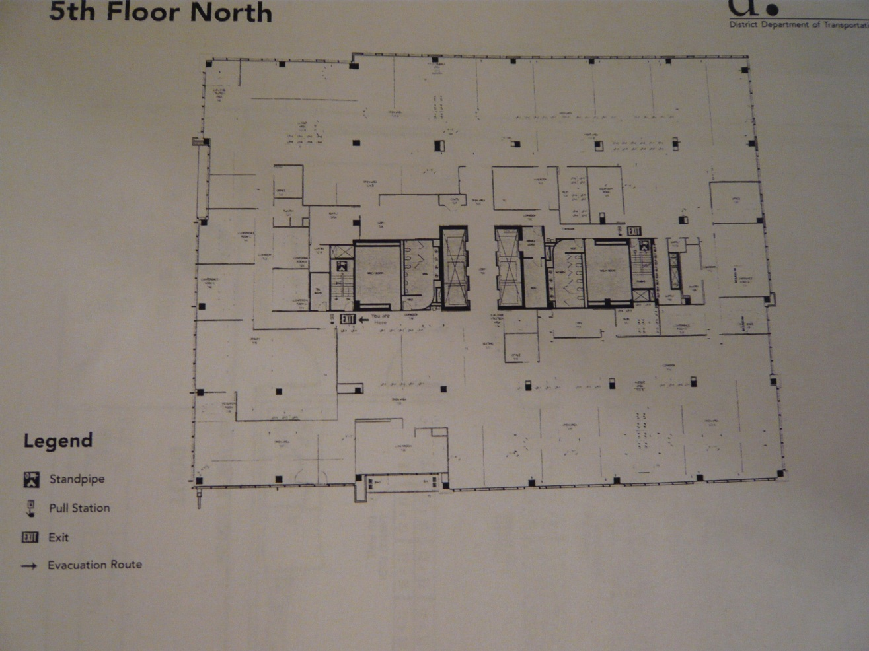
Exit
Library

5th Floor: Exit /Stairs

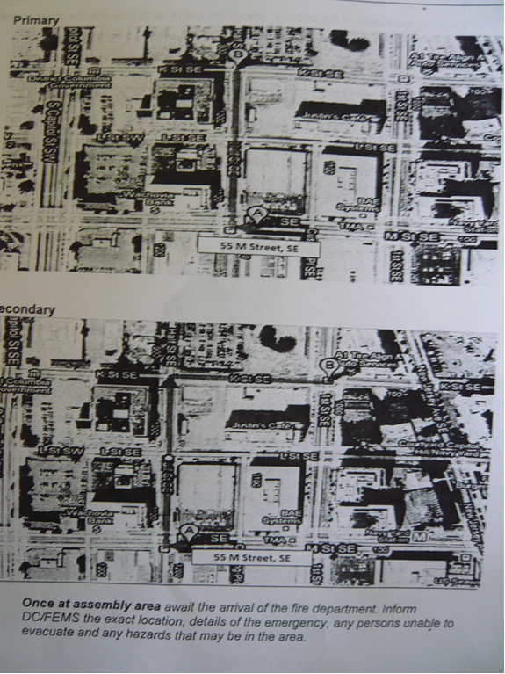

Two Assembly Areas

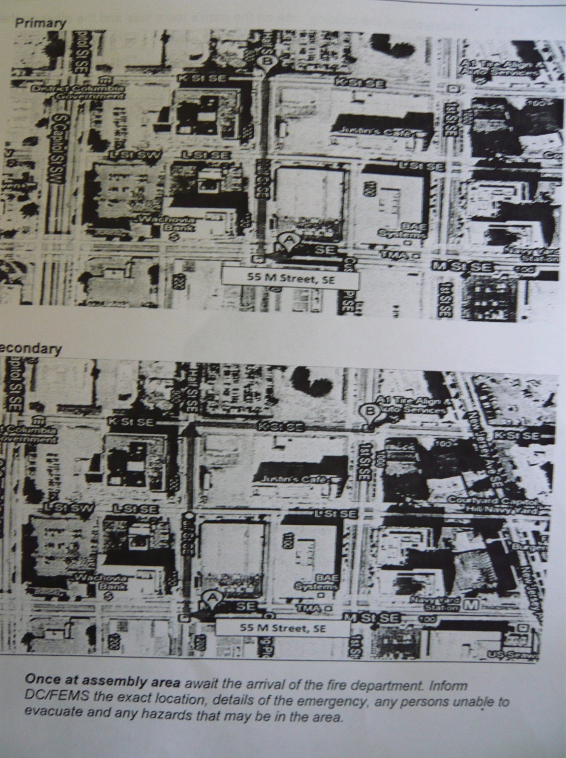

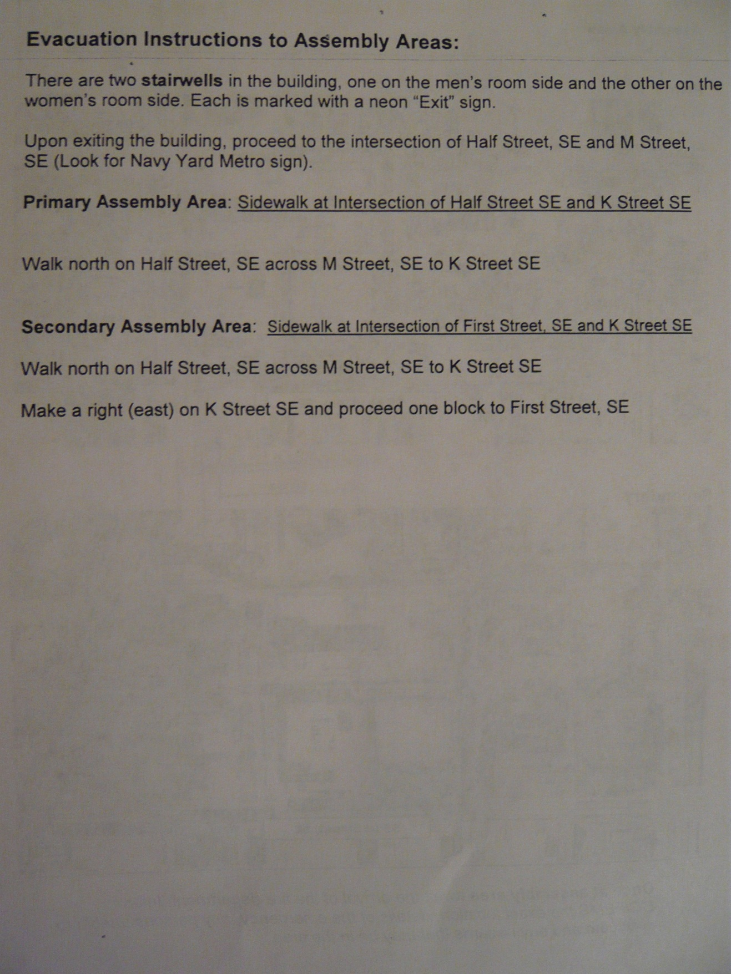
Staff Emergency Procedures

Medical Emergencies: Staff

If a staff member or volunteer is seriously ill or injured:

1. Notify your supervisor immediately.

2. Render the minimum first aid necessary and decide what additional treatment is required (call Fire Department, paramedics, ambulance, etc.).

3. Do not attempt to move a person who has fallen and who appears to be in pain.

4. Avoid unnecessary conversation with or about the ill or injured person. You might add to the person's distress or fears, increasing the risk of medical shock. Limit your conversation to quiet reassurances.

5. After the person has been taken care of and the incident is over, remain available to help the supervisor with pertinent information for a medical report or, if applicable, a Workers' Compensation report.

6. Contact Personnel for any questions concerning Workers' Compensation.

Medical Emergencies: Visitor

When an employee or volunteer observes a visitor who appears to be ill or injured:

1. Notify your supervisor immediately.

2. Render the minimum first aid necessary and decide what additional treatment is required (call Fire Department, paramedics, ambulance, other).

3. Do not attempt to move a person who has fallen and who appears to be in pain.

4. Avoid unnecessary conversation with or about the ill or injured person or members of his/her party. You might add to the person's distress or fears, increasing the risk of medical shock. Limit your conversation to quiet reassurances.

5. Do not discuss the possible causes of an accident or any conditions that may have contributed to the cause.

6. Under no circumstances should an employee or volunteer discuss any insurance information with members of the public.

7. After the person has been taken care of and the incident is over, remain available to help the supervisor with pertinent information for a medical report.

Fire
If a fire occurs in your area:

1. Remain calm.

2. Call the Fire Department.

3. If the fire is small, attempt to put it out with a fire extinguisher. Do not jeopardize your personal safety.

5. Never allow the fire to come between you and an exit.

6. Disconnect electrical equipment that is on fire if it is safe to do so (pull the plug or throw the circuit breaker).

7. Notify your supervisor of the location and extent of the fire.

8. Evacuate your area if you are unable to put out the fire. Close doors and windows behind you to confine the fire. Go to a designated area (see map).

9. Do not break windows. Oxygen feeds a fire.

10. Do not open hot doors. Before opening any door, touch near the top. If the door is hot or smoke is visible, do not open the door.

11. Do not use elevators.

12. Do not attempt to save possessions at the risk of personal injury.

13. Do not return to the area until cleared by emergency personnel.

All fires, no matter how small, must be reported to a supervisor.

Earthquakes

In the event of an earthquake:

1. Remain calm.

2. Stay in the building. Take shelter within a doorway, in a narrow corridor, or under a heavy table, desk or bench.

3. Stay away from windows, mirrors, overhead fixtures, filing cabinets, bookcases, and electrical equipment

4. Do not attempt to leave the building, as exit stairwells may have collapsed or be jammed with people.

After the earthquake has stopped:

1. Remain alert for aftershocks.

2. Listen to local radio stations for instructions.

3. Assist those who have been trapped or injured by falling debris, glass, etc. Do not move seriously injured persons unless they are in obvious, immediate danger (of fire, building collapse, etc.).

4. Evacuate the building if safe to do so. Do not re-enter until the building has been declared structurally sound.

5. Check for broken water pipes or shorting electrical circuits. Do not use a match, candle or lighter to find your way, since there may be flammable gas in the air. Shut off utilities at main valves or meter boxes. Turn off appliances.

6. Do not use the telephone, except in a real emergency. The lines should be kept free for emergency rescue operations.

7. Ensure that sewage lines are intact before running water or flushing toilets.

Explosion

1. Remain calm.

2. Be prepared for possible further explosion.

3. Crawl under a table or desk.

4. Stay away from windows, mirrors, overhead fixtures, filing cabinets, bookcases, and electrical equipment.

5. Be guided by the administration. If evacuation is ordered, go to a designated area (see map).

6. Do not move seriously injured persons unless they are in obvious, immediate danger (of fire, building collapse, etc.).

7. Open doors carefully. Watch for falling objects.

8. Do not use elevators.

9. Do not use matches or lighters.

10. Avoid using telephones.

11. Do not spread rumors.

Power Outage

If a power outage occurs:

1. Remain calm.

2. Provide assistance to visitors and staff in your immediate area.

3. If you are in an unlighted area, proceed cautiously to an area that has emergency lights.

4. If you are in an elevator, stay calm. Use the intercom or the emergency button to notify building security.

5. If instructed to evacuate, go to a designated area (see map).

Flooding and Water Damage

If a water leak or flooding occurs:

1. Remain calm.

2. Notify building maintenance and your supervisor. Give the exact location and severity of the leak. Indicate whether any part of the collections is involved or is in imminent danger.

3. Do not walk in standing water which may have contact with wiring and may be electrified. If there are electrical appliances or electrical outlets near the leak, use extreme caution. If there is any possible danger, evacuate the area.

4. If you know the source of the water and are confident of your ability to stop it (unclog the drain, turn off the water, etc.), do so cautiously.

5. Be prepared to help as directed in protecting collection materials that are in jeopardy. Take only those steps needed to avoid or reduce immediate water damage: cover shelf ranges with plastic sheeting; carefully move materials out of the emergency area. Do not remove already wet books from shelves.

EMERGENCY PLANNING & RECOVERY DOCUMENTS

Salvage of Water Damaged Collections

Books: Cloth or Paper Covers

Priority
Freeze or dry within 48 hours.

Handling Precautions
Do not move items until a place has been prepared to receive them. Do not open or close books or separate covers. Oversized books need to be fully supported, it may only be possible to move one at a time.

Preparation for Drying
Closed books that are muddy should be rinsed before freezing. If air drying is not possible, books should be frozen within 48 hours. Separate with freezer paper, pack spine down in milk crates, plastic boxes, or cardboard boxes lined with plastic sheeting.

Drying Methods
Air Drying is suitable for small quantities for books (less than 100 volumes) that are not thoroughly soaked. It requires space in an area away from the disaster to spread the books out. Books are stood upright and gently fanned open to dry. Keeps air moving at all times when using fans. Use dehumidifiers as needed to maintain humidity at or below 50 percent RH.

Oversize volumes- must lay flat and should be turned when the blotter is changed. Pages should be interleaved with sheets of un-inked newsprint or blotting paper that is changed as it becomes saturated.

Freeze Drying- (not vacuum thermal drying) is suitable for large quantities of books and books that are very wet. Pack as described above and ship to drying facility.

Vacuum Freeze Drying- is suitable for large quantities of books. Wet coated paper can only be dried by this method. Pack as described above and ship to drying facility. Pack carefully, as volumes packed with distortions will retain that distortion permanently after vacuum freeze drying.

CD-ROMs and DVDs

Priority

1.) Immediately air dry discs.

2.) Dry paper enclosures within 48 hours.

Handling Precautions

1.) Do not scratch surfaces.

Preparations for Drying

1.) Remove discs from cases. Rinse discs with distilled water. Do not rub the discs because dirt could scratch. If necessary, blot; do not rub, with a soft lint-free cloth.

Drying Methods

1.) Case and paper enclosures may be freeze dried. Do not freeze dry the discs.
Air-dry vertically in a rack.

Emergency History

In the space below, describe emergencies which have occurred. Include the date, the location within the building, the number of materials affected, recovery procedures, and the resources (time, money, personnel, etc.) needed for complete recovery from the emergency. Also note any vendors or suppliers used in recovery actions and evaluate their performance for future reference. This section should be updated after any emergency occurrence.

________________________________________________________________________________________________________________________________________________________________________________________________________________________________________________________________________________________________________________________________________________________________________________________________________________________________________________________________________________________________________________________________________________________________________________________________________________________________________________________________________________________________________________________________________________________________________________________________________________________________________________________________________________________________________________________________________________________________________________________________________________________________________________________________________________________________________________________________________________________________________________________________________________________________________________________________________________________________________________________________________________________________________________________________________________________________________________________________________________________________________________________________________________________________________________________________________________________________________________

9.) Volunteer and Intern Policies
Responsibilities of the Volunteer or Intern and Library Expectations
Volunteers and interns are expected to abide by the Libraries’ policies and procedures and external regulations that govern their actions including, but not limited to, those relating to ethical behavior, safety, confidentiality, protected health information, computer use, financial responsibility, and drug use. Volunteers and interns are expected to conduct themselves in a businesslike and courteous manner, consistent with the high quality service goals of the library. A willful disregard for or deliberate violation of the library’s policies and expectations will result in termination.
Appointments, assignments of duty, and dismissals of volunteers or interns are the responsibility of the department supervisor or Head Librarian and are not subject to the employment policies and procedures of the District Department of Transportation. Volunteers or interns must agree to a specific work program and schedule with their supervisors. They are responsible for notifying their supervisors when they are unable to report for work. If the work is being done to complete a course or degree requirement (i.e., a practicum), the library supervisor and the practicum supervisor shall agree on an assignment for the intern/practicum student.
Who May Volunteer or Serve as an Intern
It is required that all interns be enrolled in an ALA accredited school in a Library Science Master’s Program. As required by the Howard University Intern Program, the intern must be enrolled at a District of Columbia college or university.
In the case of volunteers, it is preferred that volunteers be either enrolled in an ALA accredited school in a Library Science Master’s Program or have completed their degree.
When selecting and engaging a volunteer or intern, it is the library and research department’s responsibility to be certain that the individual has adequate experience, qualifications, and training for the task he or she will be asked to perform.

10.) Archives and Photographic Archives Policies
At the present time, the archives and photographic archives sections consist of employee donated records and photos that concern the agency and have some historical value. No piece of the archives or photographic archives shall be removed without the explicit permission of the librarian. The library is currently embarking on a digitization project; the end result is scanning all the items into our Omeka system where they can be organized and accessed digitally, as well as helping with the process of organizing and preserving the physical collection.

11.) Historical Section Policies
These items may be removed from the library and circulate, though with the more fragile items this will be on a case by case basis depending on the condition.

12.) CD and DVD Policies
At this time, all CDs and DVDs (with the exception of the Training DVDs) shall be considered part of the general collection to be handled as such.

13.) Outreach
The library’s biggest outreach project is currently our social media involvement. We post weekly on the DDOT Library & Archives Tumblr page, and our Communications office cross-posts these to the DDOT Twitter and Facebook pages.

14.) Web Page
The library webpage is hosted through Google at: https://sites.google.com/a/dc.gov/ddot-research-program/ddot-library

