Research, Development, and Technology Transfer Program
Parametric Analysis of Telecommuting Effects on Transportation Tax Revenues
Scope of Work
1. Summary
The District’s Highway Trust Fund is funded by the District gas tax. The funds are used to provide the match funding for federal highway funds used to build and maintain the District’s transportation system. The District of Columbia has 1,057 miles of federal and local roadways with 21.6% in poor and 25.3% in fair conditions, and 244 bridges of which 12% are reported as structurally deficient. The District’s Highway Trust Fund is an integral source of funding to maintain this infrastructure. The adoption of electric and hybrid vehicles and decreases in road trips due to the transition to telecommuting and eCommerce, especially with the onset of the COVID-19 pandemic, are significantly influencing transportation revenue generation from gasoline taxes. This will become a serious challenge for infrastructure asset management in the near future. The project should be completed within 18 months of notice to proceed.

2. Background
According to the D.C. Tax Facts, the motor fuel tax in 2000 was reported to be $32.7 million dollars In 2017, this number had decreased to $25.1 million dollars. Transportation infrastructure is costly to build and even costlier to maintain; in 2010 the federal government spent approximately $4 billion on the construction of new highways and bridges, while $19 billion was spent on maintenance of existing highways and bridges. In 2017, The Condition of the District’s Roadways reported that the actual expenditure on the District roadways was 4.5 times higher than the FY 2010-2014 average.

3. Requirements
The main objective of this research is to investigate the most influential parameters and possible scenarios affecting the District’s Highway Trust Fund revenues due to increased telecommuting and changes in commute mode in order to propose a multi-criteria decision-making model for transportation tax revenue generation. Within the research plan, several activities are embedded into the six (6) proposed tasks, resulting in the development of a tax revenue generation model. The six proposed tasks are:

Task 1: Literature Review
In this task a comprehensive literature review will be conducted on the effects of transitioning to telecommuting and related factors such as fuel efficiency, electric and hybrid vehicles, fuel prices, and eCommerce on transportation tax revenue generation. In addition, the literature review will investigate revenue replacement strategies proposed and/or implemented in other jurisdictions for their potential efficacy to support the District’s Highway Trust Fund. Particular emphasis will be placed on strategies appropriate for the urban/city context. District transportation expenditures in the last 20 years will also be studied.

Task 2: Analyze Current Transportation Tax Revenue Models
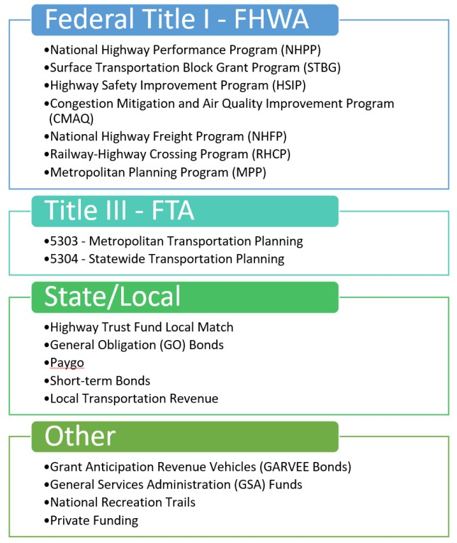
DC’s transportation expenses include the costs required to operate and maintain the current transportation system, and to expand services and infrastructure as needed. Due to inflation, real revenue value has decreased. In addition, higher vehicle fuel efficiency has further worsened revenue generation (Puro, 2013). To address the deficiency of the current funding scheme, this task will analyze the current transportation tax revenue model and the variables affecting it in the District. See Figure 1.
Figure 1. DDOT Funding Sources

Task 3: Investigate the Impact of Telecommuting on Transportation Tax Revenue and Expenditures The number of remote workers has increased by 159% since 2005 (USDOT, 2017). Although previous reports estimated that only a third of jobs can be done entirely from home, up to half of American workers are now working from home due to the COVID-19 pandemic. This has more than doubled the fraction of people who worked from home in 2017-2018 (Guyot & Sawhill, 2020). In this task, the impact of the rapid transition to telecommuting on daily travel patterns, and consequently on District transportation tax revenue generation, will be investigated. While the COVID-19 pandemic dramatically increased rates of telecommuting in the District of Columbia, this investigation will focus primarily on long-term trends towards work-from-home, while considering the effects of new telework policies and practices that have been tried during the pandemic.

Task 4: Perform a Comprehensive Survey Study on the Transitions in Mode Choice and Work Location According to an EV Adoption (2019) report, the US electric vehicle market share will increase from 3.04% in 2020 to 17.65% in 2028. Moreover, US ecommerce sales have increased by 136.7% since 2008 and are expected to grow by 30% by 2022. The survey data from the Greater Washington Partnership will be used to evaluate willingness to telecommute rather than travel for job and leisure purposes, purchasing a hybrid/electric vehicle, online shopping, as well as willingness to pay taxes for state and federal services provided. If appropriate data are not available, an additional survey study will be conducted on underrepresented groups in order to fill in gaps.

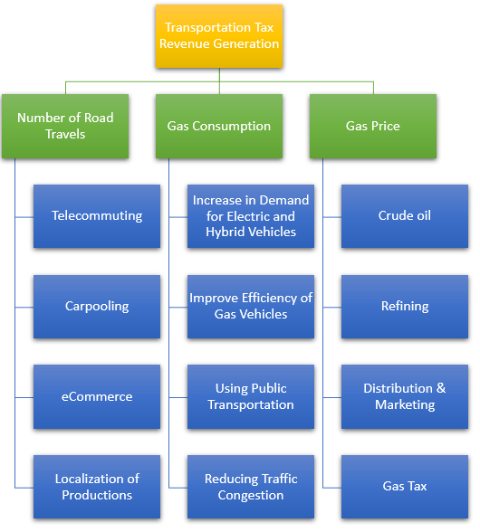
Task 5: Conduct Sensitivity Analyses
Figure 2. Main components of transportation tax revenue generation
In addition to recent rapid transitions to telecommuting, other factors influencing transportation tax revenue generation, will be analyzed, see figure 2, to develop projection models of future revenue. After identifying the main influential factors, a sensitivity analysis will be conducted for each variable to estimate its effects on revenues. Given the high uncertainty about most of these parameters, the sensitivity analysis will focus on realistically estimating transportation tax revenue generation. Subsequently, a parametric study will be conducted to analyze the correlations and interrelation between the most influential factors and transportation tax revenue generation.

Task 6: Analyze Data, Develop Model, and Evaluate Alternatives
Using the data generated from Tasks 3 through 5, along with the data extracted from current sources in Task 2, a model will be developed to predict future transportation tax revenue generation in the next 10 years and propose alternative strategies for the District to bridge the gap between the revenue lost and expenditures. This model will be developed with the assistance and consultation of DDOT and its funding information. These strategies will be the result of the sensitivity analysis and a series of what-if analyses of possible future scenarios to draw conclusions regarding models and effective policies for funding future transportation needs. These scenarios will be vetted in advance by DDOT and will be generated during a period of ongoing communication about the efficacy of the frameworks generated during the analysis process.

Task 7: Prepare Reports Including Recommendations for Implementation
An interim report to DDOT will be prepared after nine (9) months of project work which will document progress on Tasks 1-4. The final report after eighteen (18) months of project work will document the methods used and findings obtained in this project. It will include recommendations for implementing the products of this study, including specific alternatives for matching transportation revenues to the needs of transportation agencies.

Project Management
Deliverables and Project Schedule
In addition to the interim report and final report, the researchers will provide DDOT with draft materials based on the following chart. DDOT will review and return draft materials within 2 weeks of receipt for interim deliverables and within 4 weeks for the final report. Morgan State University and the University of Maryland will collaborate on all of the project’s tasks. The University of Maryland’s researchers will focus especially on Tasks 1, 3 and 5.

Task | Deliverable | Months from Notice to Proceed
 |  | 1 | 2 | 3 | 4 | 5 | 6 | 7 | 8 | 9 | 10 | 11 | 12 | 13 | 14 | 15 | 16 | 17 | 18
1 | Draft literature review
2 | Memo summarizing current transportation tax revenue model and the variables affecting it
3 | Memo on methodology to assess telecommuting and commute mode choice trends
4 | Draft survey instrument and distribution plan with explanation of need for survey
4 | Final survey results
7 | Draft interim report
5 | Report on sensitivity analysis findings
6 | Alternatives Draft #1
6 | Revised alternatives report
7 | Draft Final Report
7 | Final Report Due

Key Personnel:
The project will be conducted as a collaboration between Morgan State University (Lead) and University of Maryland. The project will be successfully managed by PI, Dr. Mehdi Shokouhian (Assistant Professor), and Co-PIs Dr. Oludare Owolabi (Assistant Professor), Dr. Steve Efe (Assistant Professor), from Morgan State University, and Dr. Paul Schonfeld (Professor) from University of Maryland, over an 18-month period.
The project team will work closely to achieve the objectives of the project by staying on schedule and within budget. The research team will have weekly meetings to discuss the progress of the project to meet the deliverables presented. In addition to the PIs, one postdoc researcher from MSU and one graduate researcher from UM will work on the tasks to compile relevant papers, aid with developing the survey questionnaire, data collection, and analyses.
Dr. Mehdi Shokouhian (PI) is an Assistant Professor in the Department of Civil Engineering at Morgan State University. He joined MSU in 2015 to pursue his postdoctoral research. He received his PhD degree in Civil Engineering from Tsinghua University in 2015. Previously, he was faculty lecturer in the Department of Civil Engineering at Azad University (IAU) in Iran from 2002-2010. His main research area is performance-based design of structures made of high-performance materials using theoretical, numerical and experimental methods. His doctoral research specifically focused on design code development of high strength flexural members for bridges and building structures. Dr. Shokouhian has over 20 years of experience in teaching, research, and professional field. He has published more than 50 peer reviewed articles and served as reviewer and editorial board for more than 10 reputable journals. He was Co-PI in the previous UMEC projects, and has actively participated in a number of state and federal research projects.
Dr. Oludare Owolabi (Co-PI) is the Associate Chair and the Director of the Center for Advanced Transportation and Infrastructure Engineering Research at the Department of Civil Engineering at Morgan State University Baltimore. He joined the faculty of the Department of Civil Engineering at MSU in 2010 after working in the industry for about three years following the completion of his doctorate degree at the George Washington University in 2007. He has more than 25 years of outstanding experience in practicing, teaching, and research in civil and transportation engineering. He is an expert in advanced modeling and computational mechanics. He has served as a member of organizing committees of numerous international conferences, and chaired 14 international conferences. He is also a registered Professional Engineer in the state of Maryland. He is presently a member of the Transportation Research Board Committee on Seasonal Climatic Effects on Transportation Infrastructure (AFP50).
Dr. Steve Efe (Co-PI), an Assistant Professor and the Assistant Director of the Center for Advanced Transportation and Infrastructure Engineering Research. He obtained his Doctor of Engineering in Civil Engineering with a major in Structural Engineering and minor in Construction from Morgan State University. He has more than 15 years of outstanding experience in practicing, teaching, and research in civil and transportation engineering. He is experienced in project management, inspection and construction supervision, adaptive materials and construction techniques, high performance material testing and simulations, material modeling and computational mechanics.
Dr. Paul Schonfeld (Co-PI) is a Professor of Civil Engineering at the University of Maryland, where he served for 19 years as Director of its Transportation Engineering Program. He has B.S. and M.S. degrees from MIT and a Ph.D. from the University of California at Berkeley. He has worked on analyzing various transportation systems, including public transportation systems, road networks and traffic management systems, air transportation systems, freight logistics, and inland waterways. His publications include 173 accepted for peer-reviewed journals. He is a Fellow of ASCE and ITE and has served as Editor of the Journal of Advanced Transportation and ASCE’s Journal of Transportation Engineering. 26 of his PhD students have accepted university faculty appointments. He received ASCE’s 2018 James Laurie Prize for career achievements in transportation engineering.

